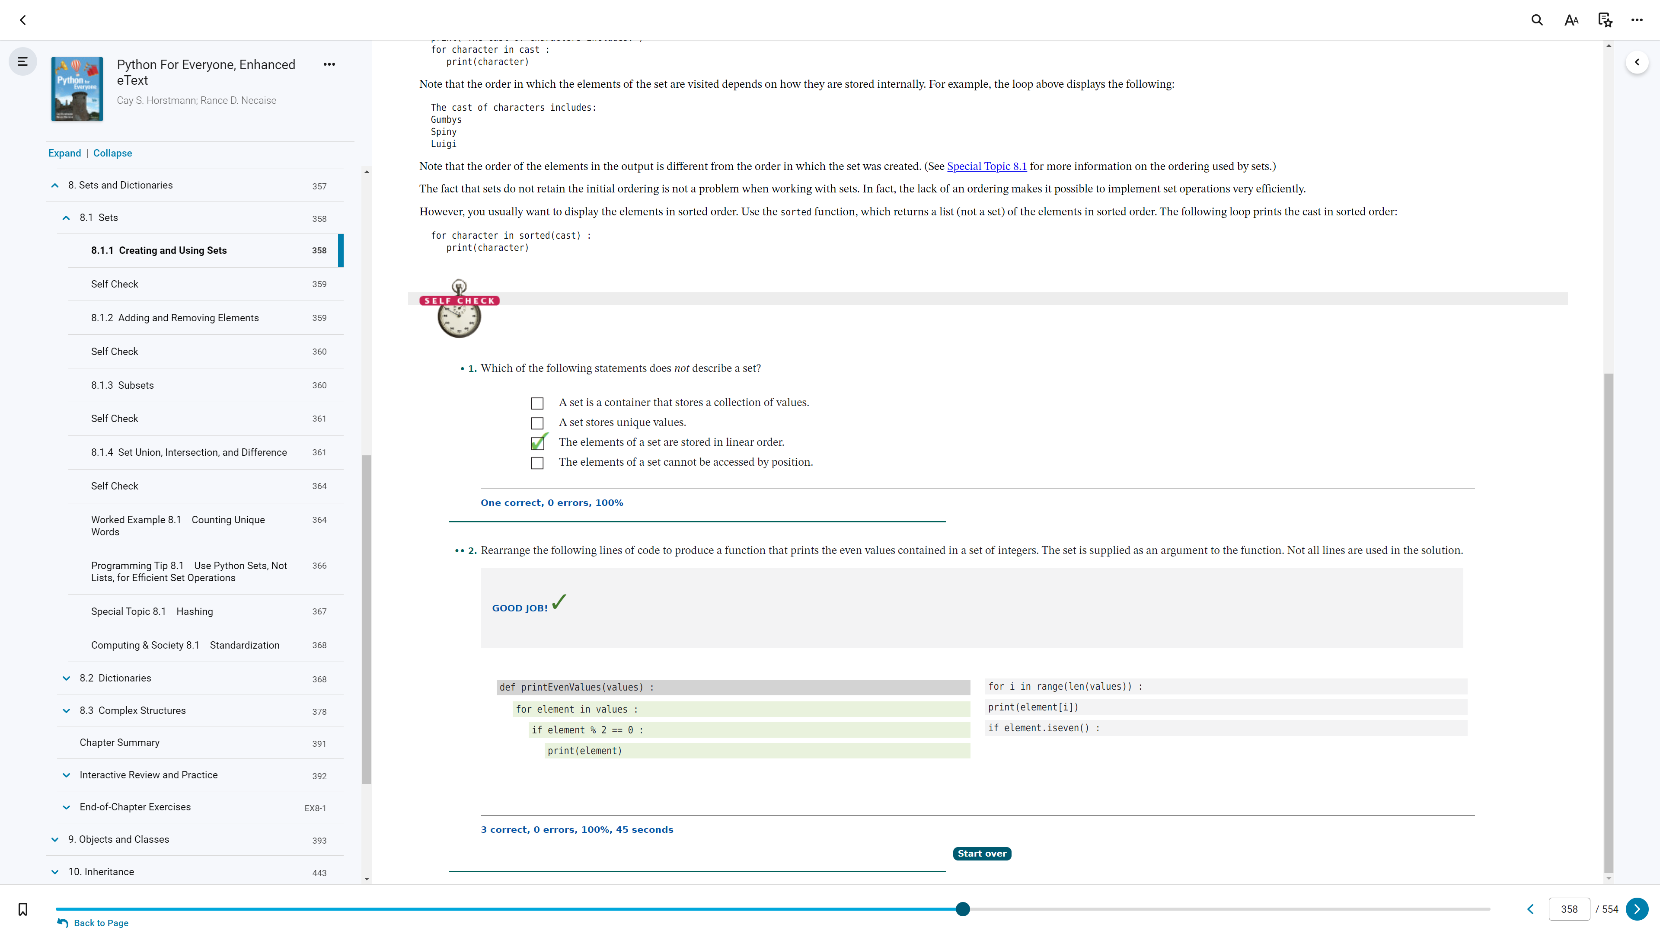

8.1.1

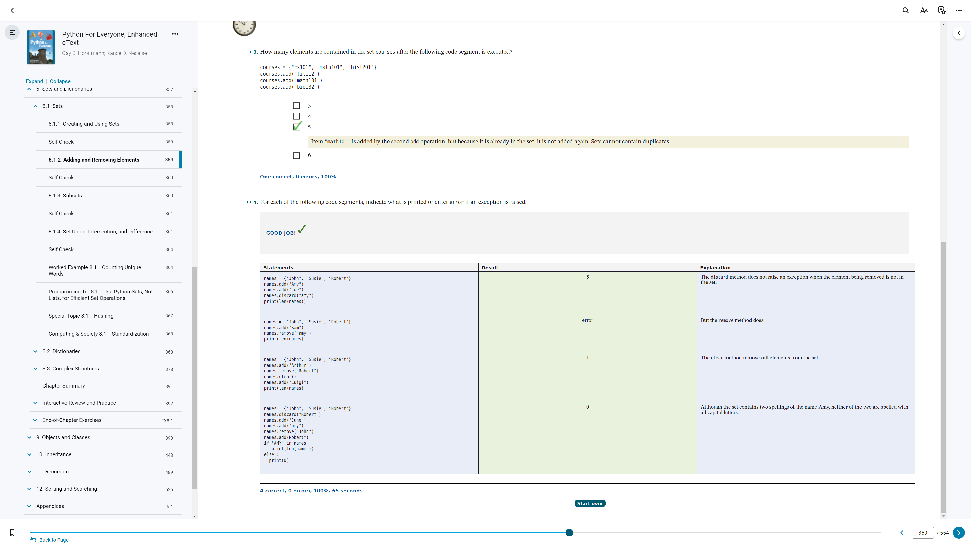

8.1.2

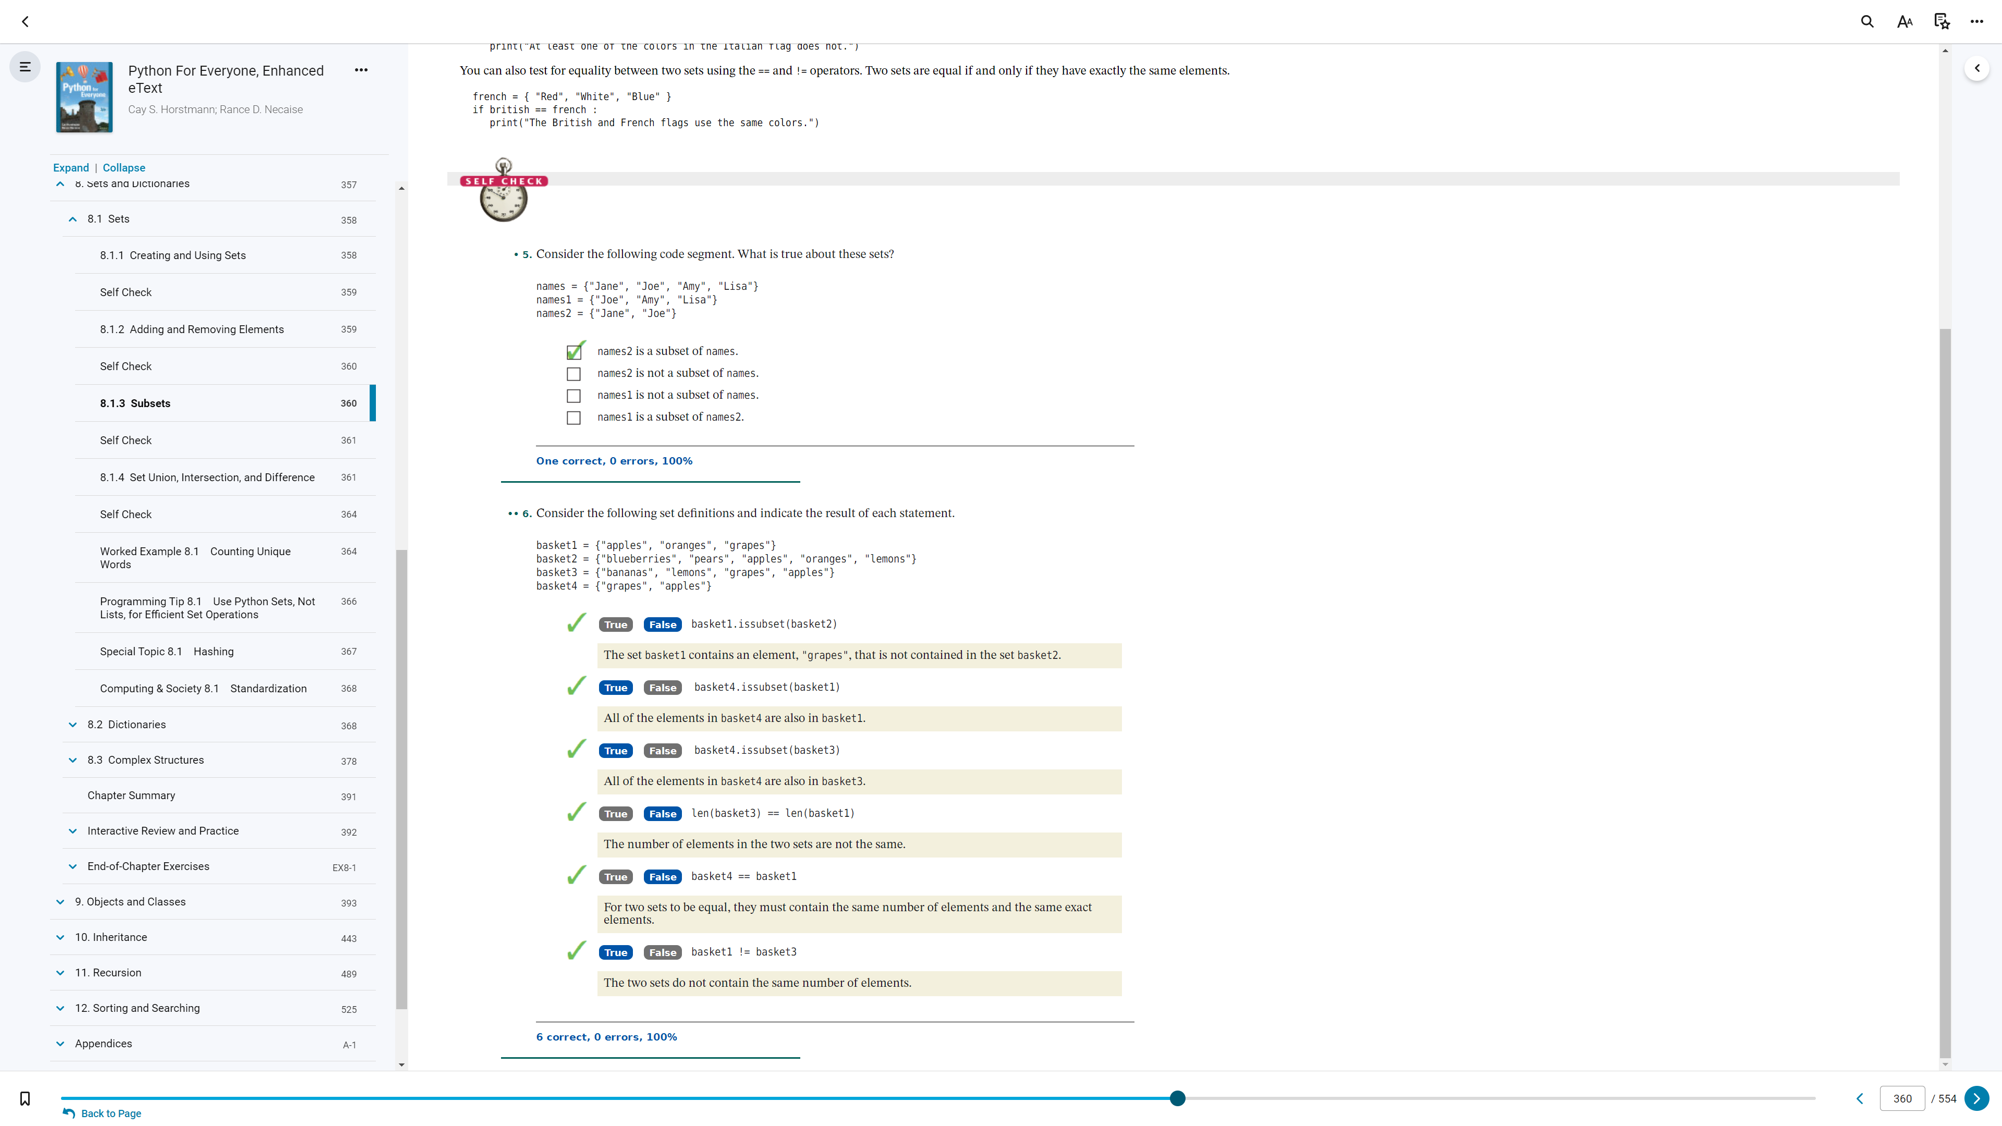

8.1.3

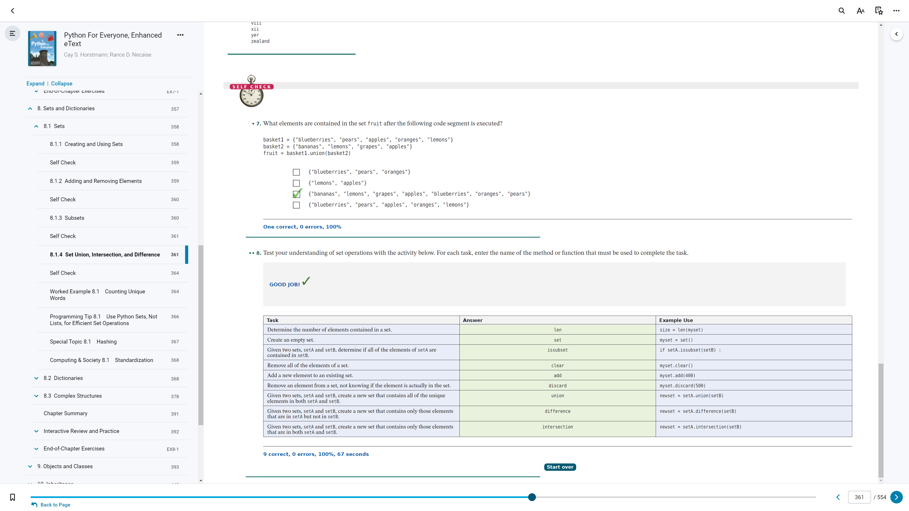

8.1.4

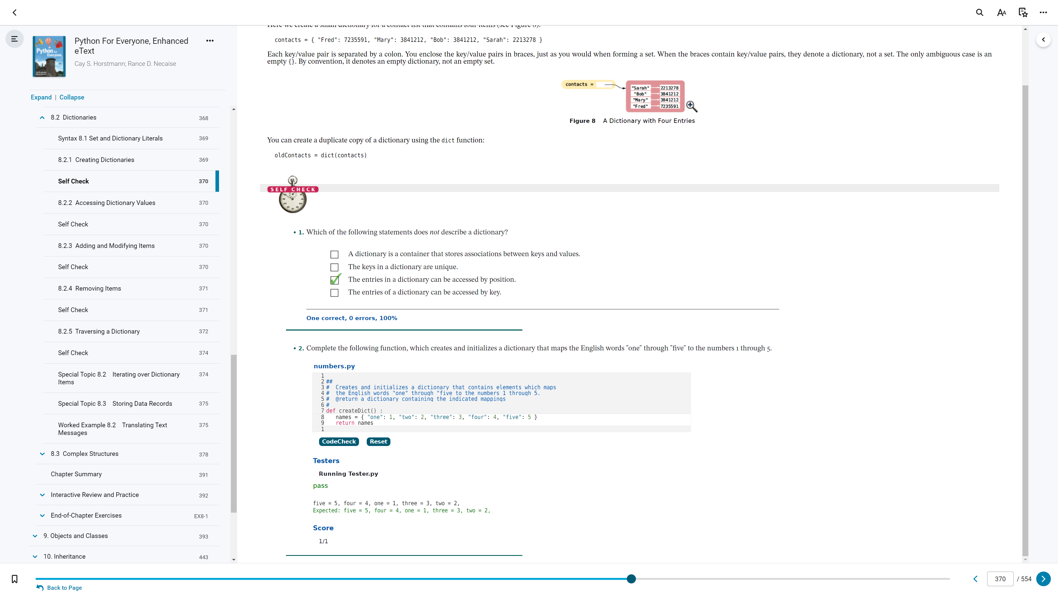

8.2.1

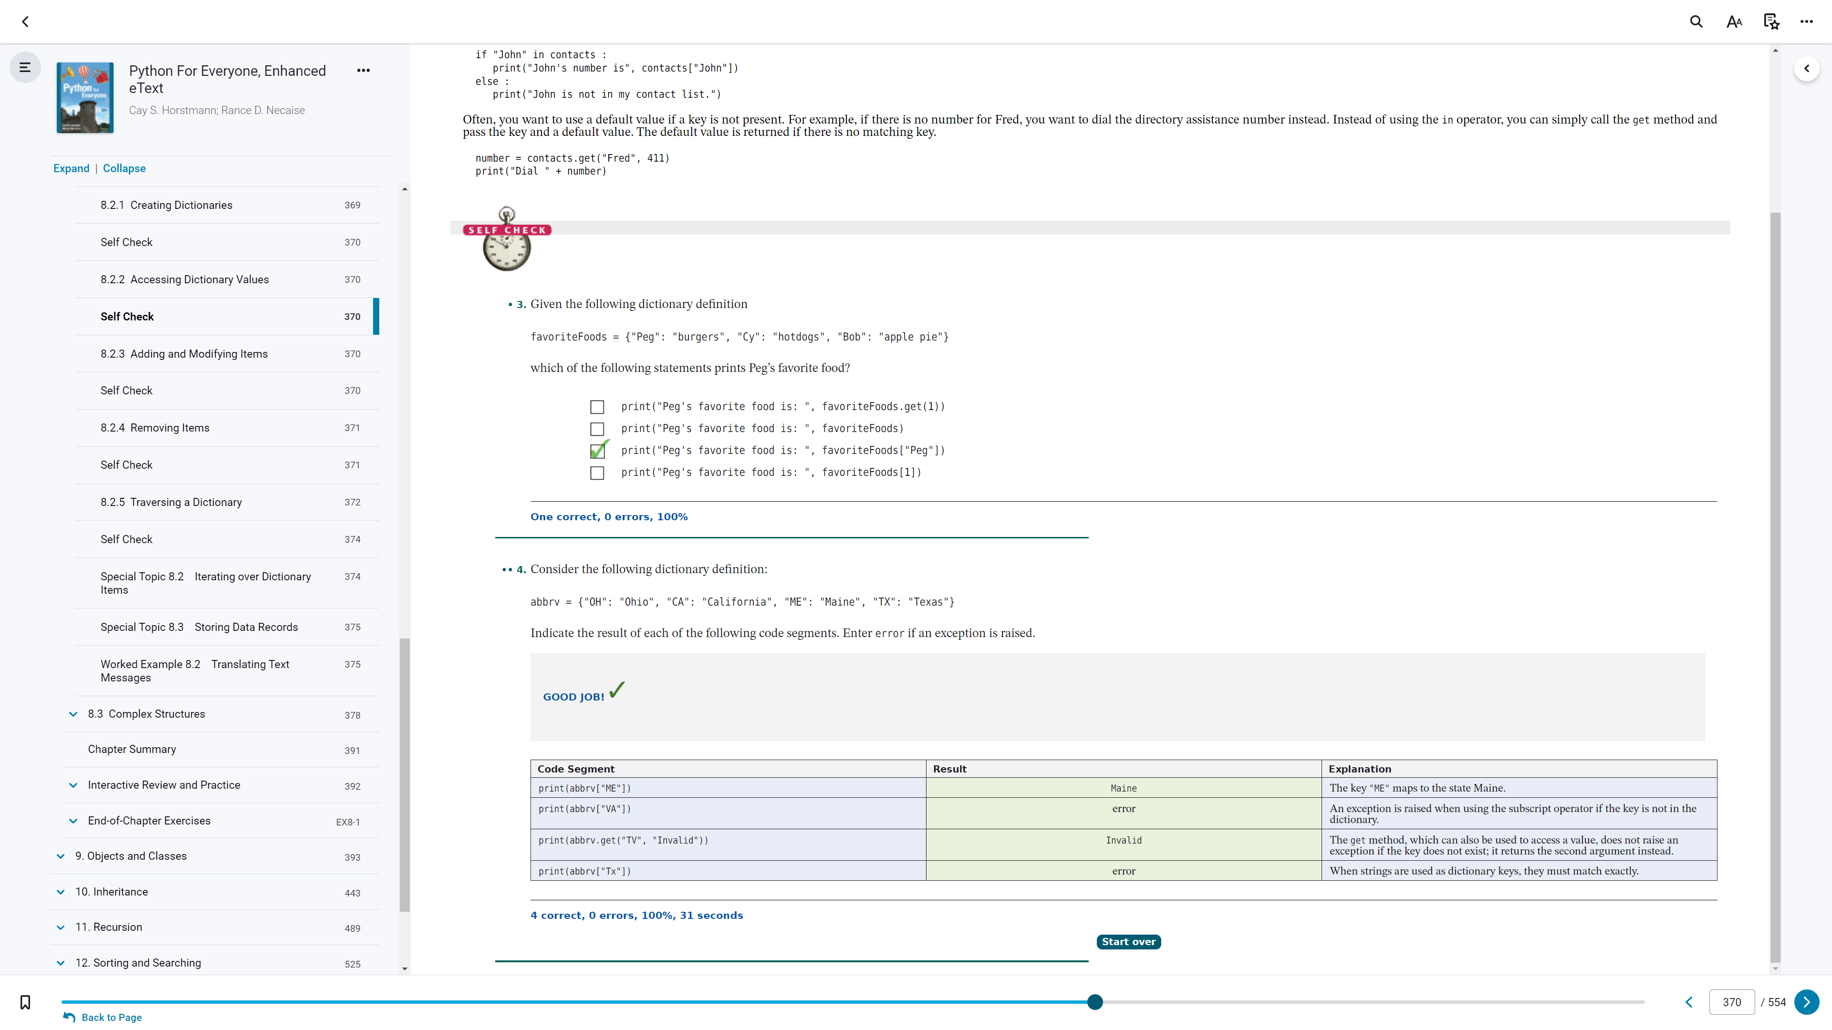

8.2.2

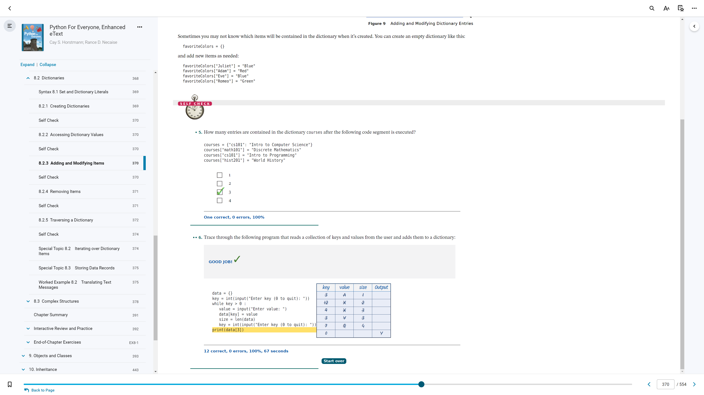

8.2.3

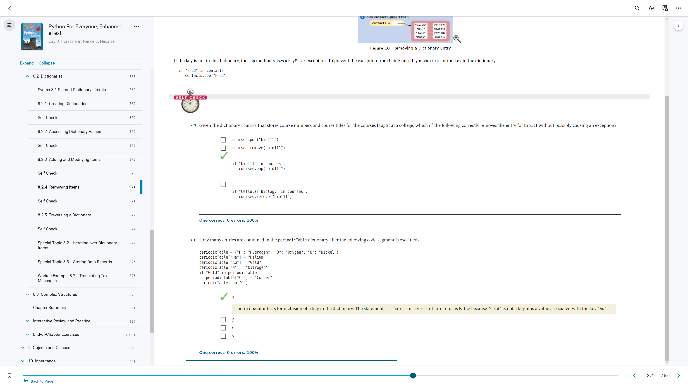

8.2.4

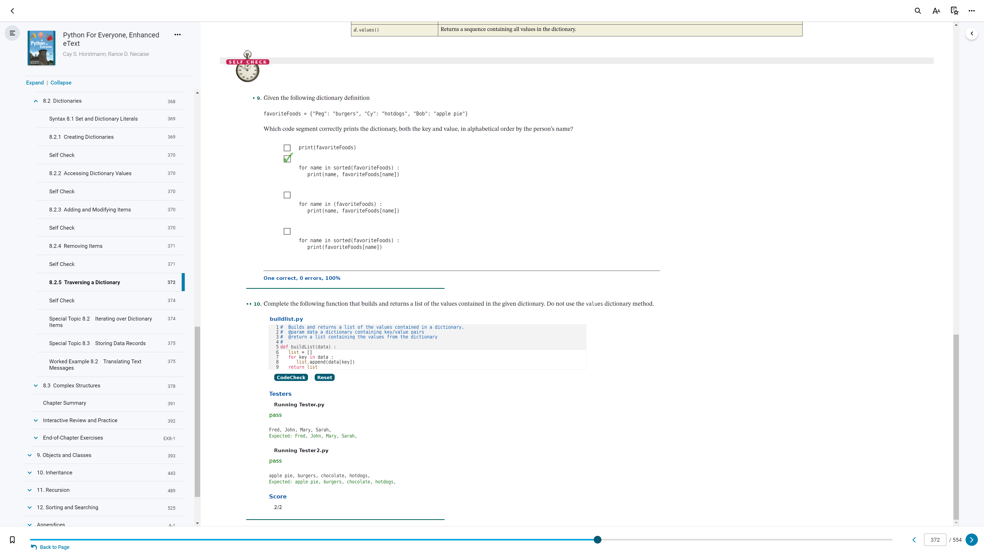

8.2.5

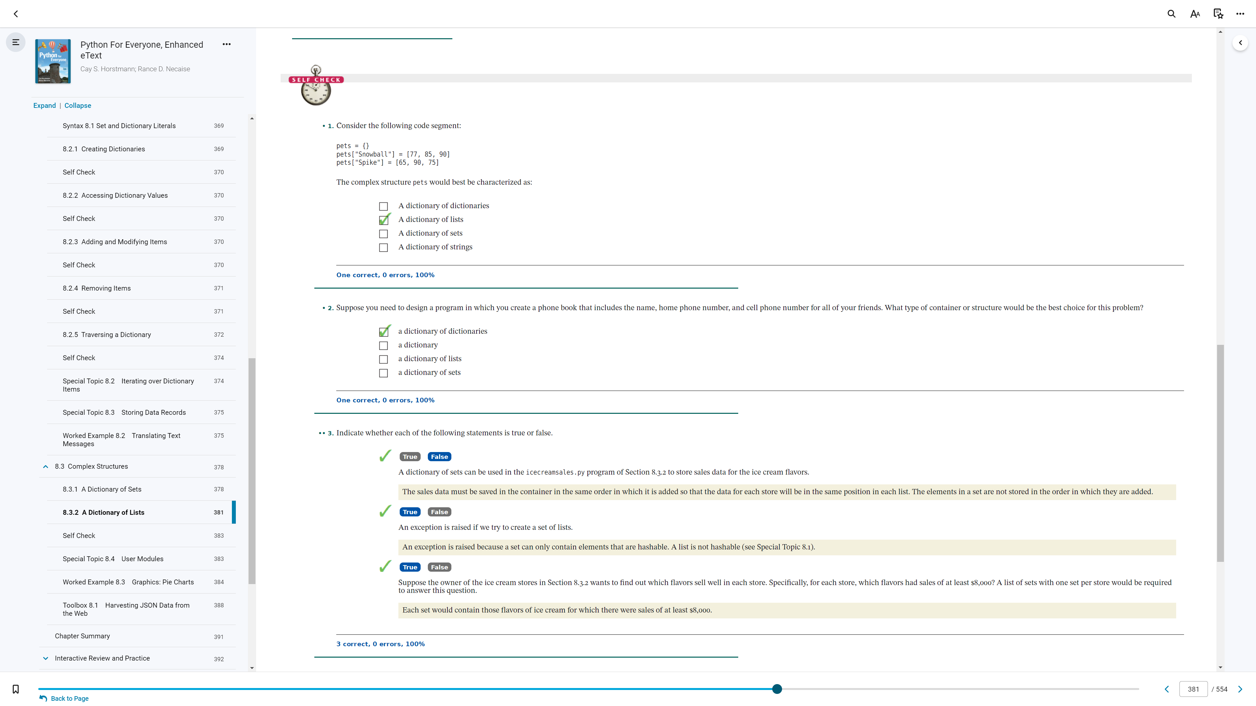

8.3.1/2

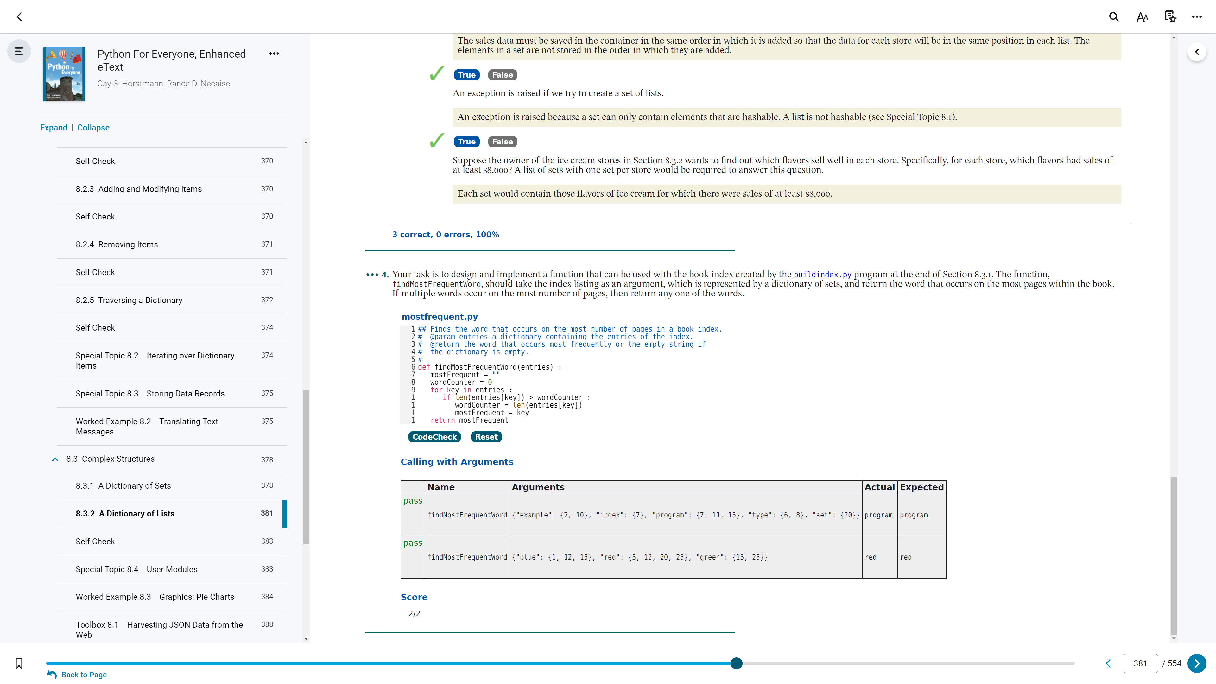

8.3.1/2_

8.1.1 - Creating and Using Sets (1, 2)
8.1.2 - Adding and Removing Elements (3, 4)
8.1.3 - Subsets (5, 6)
8.1.4 - Set Union, Intersection, and Difference (7, 8)
8.2.1 - Creating Dictionaries (1, 2)
8.2.2 - Accessing Dictionary Values (3, 4)
8.2.3 - Adding and Modifying Items (5, 6)
8.2.4 - Removing Items (7, 8)
8.2.5 - Traversing a Dictionary (9, 10)
8.3.1/2 - A Dictionary of Sets/Lists (1, 2, 3)
8.3.1/2_ - A Dictionary of Sets/Lists (4)

